# Requirements Catalogue

## Hardware requirements:

1. Laptop/Computing device

A device to research and perform our coding and implementation. The main codes and software will be run through this device. Also, all the outputs that should come out on the database will be stored in its drive.

1. GPU (Graphic Processor Unit)

GPU is required for Machine learning that will be done in this project. CPU can also be utilized if GPU is not available. But definitely will recommend having a GPU as it will save a lot of time on machine learning.

1. RAM (above 8GB)

RAM will determine the process faster on certain types of operations. Having more RAM will increase the performance of the project.

1. Camera setup / Webcam

This setup is required for the input of data. The live video feed will be using the camera to run and process the displayed characters, which in our case is the license plate numbers.

### Software requirements:

1. 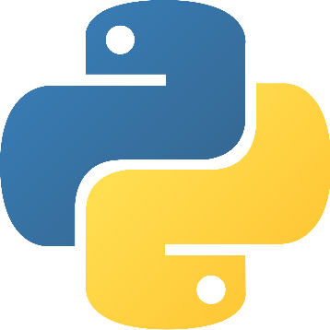PYTHON

Python is an object-oriented, high-level programming language with dynamic semantics that is construed. Its strong built-in data types, mixed with flexible editing as well as flexible binding consider it very appealing for Faster system Development while also using as a typescript or glue syntax to attach existing modules. Python's convenient, user - friendly language prioritizes readability, lowering the expense of program construction Python includes assistance for components and packages, that promotes methods and practices as well as refactoring.

1. JUPYTER NOTEBOOK

Jupyter Notebook is a free and open-source web application that lets you build and manage data with live script, symmetries, templates, and statistical analysis. Some used are: Data screening and modification, simulation analysis, data analysis, application development, and artificial intelligence.

1. VISUAL STUDIO CODE

Microsoft's Visual Studio Code is a source-code editor. Syntax editing, debugging, intelligent code matching, fragments, bug fixes, and integrated Git are among the few of many features.

1. OPENCV

OpenCV is a massive open-source framework for machine learning, algorithms, and image recognition, and it currently performs a significant part in real time functions which is critical in modern technologies.

1. TENSORFLOW

TensorFlow is a machine learning development kit which is an open-source software. It could be used for a variety of applications, though it mainly focuses on deep learning models training and testing. Tensorflow is an expressive mathematical library built on datatypes and distinct algorithms.

1. 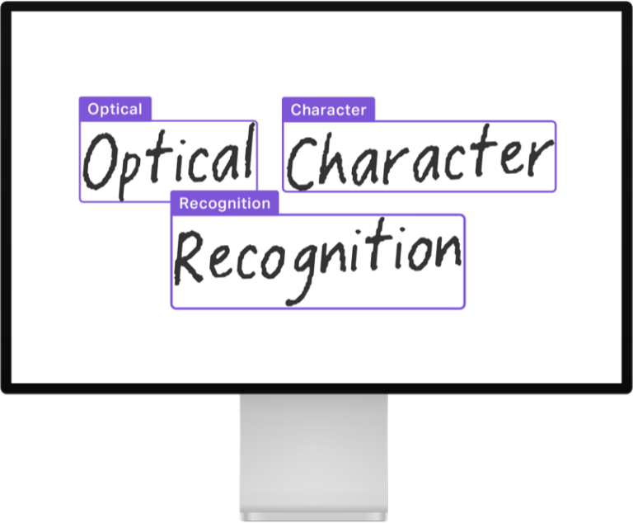EASYOCR

EasyOCR is a Python tool which enables users to translate images into textual format. This is perhaps the best method of implementing OCR as it supports more than 70 languages, such as English, Hindi, Devanagari, Chinese and several more. EasyOCR is a developed by the Jaided AI business.

1. NVIDIA GPU

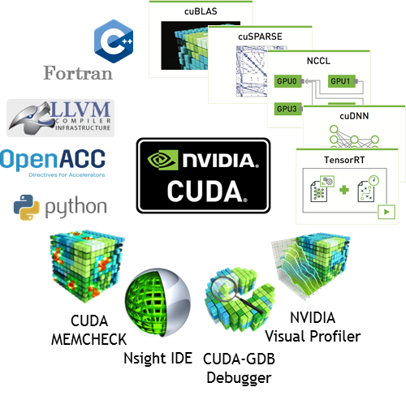Nvidia GPUs widely popular for machine learning and rapid analysis because of Nvidia's CUDA API, that allow developers to make use of the larger multiple cores available in GPUs to use BLAS operations, that are highly needed in machine learning models.

1. CUDA

Nvidia's CUDA is a serial processing platform and application programming interface framework. It helps programmers and developers to use a CUDA-enabled graphics card for specific processing – a process known as GPGPU.

1. CUDNN

CUDA Deep Neural Network (cuDNN) by NVIDIA is a primate package using graphic processor for deep learning techniques. This provides amazing optimized variants of procedures that are often encountered in DNN algorithms.